Report on Fleet Street Heritage exhibition in Septembere 2023
Summary_______________________________________________________
Our participation in the Open House was designed to make the Fleet Street Heritage Project more widely known, and to demonstrate that having a large number of heritage information pages displayed in public together would generate plenty of public interest.
Construction of the exhibit________________________________________
Fleet Street Heritage CIC has no staff, so all the work of planning and constructing this exhibit fell on the CEO. The information panels were printed by the local KallKwik copy shop on large plastic sheets: 2 measured 3 m by 1 m and contained 18 of our panels, and 2 were 1.7 m by 1m with 10 panels. These sheets took 7 days to produce, and were thus not available when the frameworks were constructed in Salisbury. The timber for these frameworks had to be brought to London by train. The final construction was done on the street in London. The method of fixing the sheets to the framework was sub-optimal due to these constraints.
Mounting the exhibit on site._______________________________________
We had been told by the planning authority that we did not need planning permission so long as there was no mechanical fixing to the wall. The lightweight timber frames were therefore lent back on the wall. Windy conditions on the fourth day of the exhibition caused all four of the frames to be tipped forward on to the street, fortunately at a time no-one was there. (See pictures below)
Why was our exhibition part of the Open House 2023?__________________
The Open House events are held every year in mid-September, This year 733 buildings and events were included. Their website gets a very large number of hits, including our entry of 724 events spread over the four days from Friday 17th to Sunday 21st September. Their website gets a huge amount of publicity, so it was obviously better for us to participate in this event rather than to mount an exhibition independently. Our exhibition was presented as a joint event between the Heritage Sundial at the top of the wall, and the exhibition of heritage panels at the foot of the wall. The exhibition was presented in the form of 6 Q and A events a day - 3 of these were Sundial Q and A’s at 8,9,and 10 am when the sundial would have sunshine on it, and 3 were Heritage Q and A’s at 11,12 and 1 pm.
What were the results?__________________________________________
The results were very gratifying. We had 63 attendees registered in advance (Thurs 21, Fri 23, Sat 6, Sun 13). Many more visitors came from casual passers-by from Fleet Street. Visitors were curious about how the east-facing sundial worked, and interested in the detail of some of the 56 heritage panels included in our exhibitors. They were also shown the excellent book, produced this week by the Fleet Street Quarter which contains 70 of our pages, and many of them expressed a wish to buy the book when it goes on public sale.

Acknowledgements____________________________________________
Our main thank-you must be to the organisers of the Open House, who created this great opportunity to advance our objectives. The Fleet Street Heritage Project has been largely funded by the Community Infrastructure Levy Neighbourhood Fund of the City of London. We have worked closely with the Fleet Street Quarter, who kindly produced the book of all our pages to a very tight schedule so it would be in time for the Open House.. We were much helped by individuals who volunteered to assist our efforts on site, particularly Jessica, Kishan, Veronika, Megan, Gillian and Luke

The petition___________________________________________________
We asked all our visitors to sign the petition given below, and around 168 of them did so. The petition read
“We urge the City of London Corporation to do everything in its power to establish a permanent,, openly accessible exhibition of ceramic tiles incorporating as many as possible of the Fleet Street Heritage information panels as displayed at the Open House 2023”

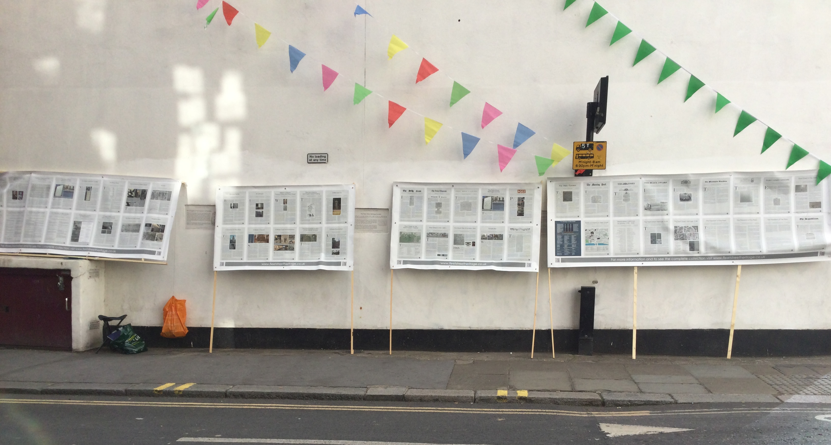
◦
Fleet Street Heritage CIC
Piers Nicholson, CEO
piersnic@gmail.com
07 909 747 335

